Step 12. Arrange with your chosen airline to sign the
captain’s declaration
Step 13. Present your pet’s import licence during check in
Step 6. Dog owners: Apply for a dog licence (Note: You need to
include dog’s microchip number & address where dog will be kept)
Step 7. Apply for an import licence (Also include the dog licence number during application)
Step 8. Book inspection after import licence (step 7) is approved. (Attach the flight details)
Step 9. Please refer to Customs website on Importing Personal Pets for import procedures and GST payment.

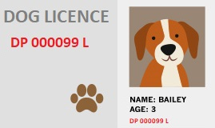
CATEGORY B
Austria, Belgium, Bermuda, Cayman Islands, Denmark, Finland, France, Germany, Hong Kong SAR, Iceland, Italy, Japan, Jersey, Liechtenstein, Luxembourg, New Caledonia, Norway, Portugal, Sweden, Switzerland, The Netherlands, USA (Hawaii and Guam only)

Is test results
≥ 0.5 IU/ml?
Is your
pet vaccinated against rabies?
Please download this PDF document. Best viewed in Adobe Reader.
≥ 30 days
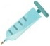
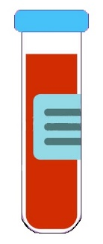
Step 4. Send pet for rabies serology
test ≥ 30 days after rabies vaccination date
Step 3. Send pet for
rabies vaccination
Yes
7 to 30 days
TIMELINE BEFORE ARRIVAL
≥ 2 months
Step 1. Ensure
- the breed of your dog/cat is allowed in Singapore
- your dog/cat is allowed in the intended residence in Singapore
- your dog/cat has stayed in exporting country continuously for at least 6 months or since birth
Step 2. Microchip your dog/cat according to International Standards Organisation (ISO) Standard 11784 or ISO Standard 11785 Annex A (the microchip no. must be indicated in all vaccination/treatment records)
Step 5. Send pet for vaccinations
- Dog: Canine Distemper, Canine Hepatitis &
Canine Parvoviral infection
- Cat: Cat Flu (Feline Calicivirus and Feline Viral Rhinotracheitis)
& Cat Enteritis (Feline Panleukopaenia/ Feline Parvovirus)
Step 10. Send pet for external & internal parasite treatments and request treating vet to complete Sections I to III of the veterinary certificate
Step 11. Visit the exporting country’s official government vet to
endorse Section IV of the same veterinary certificate
2 to 7 days (arrival day = day 1)
Just before departure
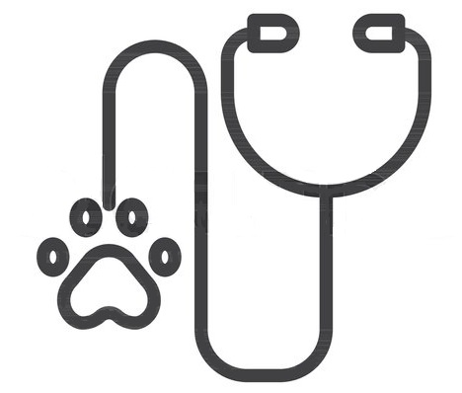
Check the costs, service standards and validity for these e-services
- Dog Licence
- Import Licence
- Inspection
Refer to step-by-step guides for these e-services
- Dog Licence
- Import Licence
- Inspection (Creating an account; Booking inspection)
Avoid booking these inspection timings
- Mon to Sat 10:30PM to 8AM
- Sun & public holidays
Start to prepare
- Flight arrangements for you and/or your pet
- Pet crate that complies with your chosen airlines (for your pet during the flight to Singapore)
- Residence for yourself and your pet
≥ 2 weeks
No
Yes
Has pet
gone for serology test ≥ 30 days after rabies vaccination?
Yes
Is
vaccination valid
as at arrival
date?
No
No
PET ARRIVAL DATE
No
Yes

Ensure the breed of your pet is allowed in Singapore
Breeds of Dogs not allowed in Singapore | Breeds of Cats not allowed in Singapore
- Pit Bull, including  - American Pit Bull Terrier (which is also known as the American Pit Bull and Pit Bull Terrier)  - American Staffordshire Terrier  - Staffordshire Bull Terrier  - American Bulldog  - Crosses between them and other breeds  - Akita  - Neapolitan Mastiff  - Tosa  - Dogo Argentino  - Fila Brasileiro  - Boerboe  - Perro De Presa Canario  - Crosses of the above | - 1st to 4th generation Bengal or Savannah cat crosses  If you intend to import either a Bengal or Savannah cross breed cat, you need to show documentary proof that your:  - Bengal cat cross is at least a 5th generation cross from the ancestral stock of Prionailurus bengalensis  - Savannah cat cross is at least a 5th generation cross from the ancestral stock of Leptailurus serval
= Back To Top =

Ensure your pet is allowed in the intended residence in Singapore
Type of Dog/Cat | Housing Development Board (HDB) residential flat  (No. of dog/cat allowed per residential unit) | Non-HDB residential premises  (No. of dog/cat allowed per residential unit)
Non-Specified dog | 1 | Up to 3
Specified dog | 0 | 1 (Out of 3 dogs, a maximum of 1 Specified dog is allowed)
Cat | 0 | Check with your residential management for specific rules for keeping cats
= Back To Top =

E-services: Cost, Processing Service Standard and Validity
Category | 1-year licence* | 2-year licence* | 3-year licence* | One-time licence@
Dogs below five months of age | $15 per dog | N.A. | N.A. | N.A.
First three dogs. | Sterilised:  S$15 per dog  Non-sterilised:  S$90 per dog | Sterilised:  S$25 per dog  Non-sterilised:  S$165 per dog | S$230 per non-sterilised dog | $35 per sterilised dog
Fourth and subsequent dog. | S$180 per dog  or  A reduced licence fee of S$15 for the fourth dog**. | $325 per dog  or  A reduced licence fee of S$25 for the fourth dog**. | $460 per non-sterilised dog | $460 per sterilised dog  OR  A reduced licence fee of $35 for the fourth dog

Licence to Import/Export/Transship Animals, Birds, Eggs and Biologics (Personal)  Also known as personal pet import licence | S$50 (normal service) | Issued within 2 working days of submission of ALL required documents | 30 days from date of issuance
 | S$100 (express service) | Issued within 1 working day of submission of ALL required documents
Pet inspection upon arrival | Free  (S$80 will be charged if inspection is not booked) | Monday, Wednesday, Friday 0800H-2230H  Tuesday, Thursday 0900H – 2100H  Saturday 1000H - 2230H  Sunday and Public Holiday Closed  Pet transfer hours (from CAPQ to AQC):  Mondays – Saturdays:  10.30 am – 11 am | -

= Back To Top =

